CONVERSION FUNCTIONS

EXECUTES ON ONE DATA TYPE AND GIVES RESULT IN ANOTHER DATATYPE.

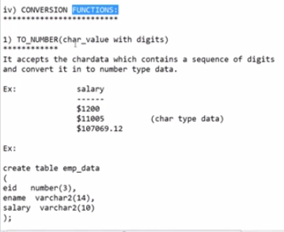

WE SHOULD CONTAIN DIGITS TO CONVERT

SQL> SELECT TO_NUMBER(SUBSTR('$100',2)) FROM DUAL;

TO_NUMBER(SUBSTR('$100',2))

---------------------------

100

SQL> SELECT 'Rupees'||TO_NUMBER(SUBSTR('$100',2))/70 FROM DUAL;

'RUPEES'||TO_NUMBER(SUBSTR('$100',2))/70

----------------------------------------------

Rupees1.42857142857142857142857142857142857143

SQL> SELECT 'Rupees' || TO_NUMBER(SUBSTR('$100',2))/70 FROM DUAL;

'RUPEES'||TO_NUMBER(SUBSTR('$100',2))/70

----------------------------------------------

Rupees1.42857142857142857142857142857142857143

SQL> SELECT 'Rupees' || TO_NUMBER(SUBSTR('$100',2))/70 FROM DUAL;

'RUPEES'||TO_NUMBER(SUBSTR('$100',2))/70

----------------------------------------------

Rupees1.42857142857142857142857142857142857143

SQL> SELECT 'Rupees' || TO_NUMBER(SUBSTR('$1000',2))/70 FROM DUAL;

'RUPEES'||TO_NUMBER(SUBSTR('$1000',2))/70

----------------------------------------------

Rupees14.2857142857142857142857142857142857143

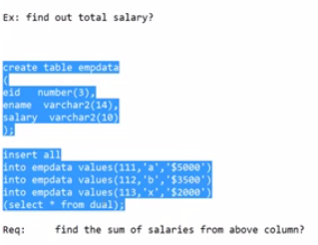

SQL> create table empdata

2 (

3 eid number(10),

4 ename varchar2(10),

5 salary varchar2(10)

6 );

Table created.

SQL> insert all

2 into empdata values(111, 'a', '$5000'),

3 into empdata values(112, 'b', '$3500'),

4 into empdata values(113, 'x', '$2000'),

5 (select * from dual);

into empdata values(111, 'a', '$5000'),

*

ERROR at line 2:

ORA-00928: missing SELECT keyword

SQL> ed\

SQL> ed

Wrote file afiedt.buf

1 insert all

2 into empdata values(111, 'a', '$5000')

3 into empdata values(112, 'b', '$3500')

4 into empdata values(113, 'x', '$2000')

5* (select * from dual)

SQL> /

3 rows created.

SQL> select * from empdata

2 ;

EID ENAME SALARY

---------- ---------- ----------

111 a $5000

112 b $3500

113 x $2000

SQL> -- here salary is in char data type

SQL> -- need to convert to number datatype to do some arith metic operations on sal.

SQL> -- can convert by using to _number function

SQL> -- but first we need to remove currency symbol by using sub string

SQL> -- substr(salary, 2) then $ symbol will be removed

SQL> select salary from empdata;

SALARY

----------

$5000

$3500

$2000

SQL> select substr(salary,2) from empdata;

SUBSTR(SALARY,2)

------------------------------------

5000

3500

2000

SQL> select sum(substr(salary,2)) from empdata;

SUM(SUBSTR(SALARY,2))

---------------------

10500

SQL> select sum(to_number(substr(salary,2))) from empdata;

SUM(TO_NUMBER(SUBSTR(SALARY,2)))

--------------------------------

10500

SQL> -- actually we get error if we use directly without converting into number datatype.

SQL> select sum(to_number(substr(salary,2))), avg(to_number(substr(salary,2))), max(to_number(substr(salary,2))), min(to_number(substr(salary,2))) from empdata;

SUM(TO_NUMBER(SUBSTR(SALARY,2))) AVG(TO_NUMBER(SUBSTR(SALARY,2)))

-------------------------------- --------------------------------

MAX(TO_NUMBER(SUBSTR(SALARY,2))) MIN(TO_NUMBER(SUBSTR(SALARY,2)))

-------------------------------- --------------------------------

10500 3500

5000 2000

SQL> select sum(to_number(substr(salary,2))) sum, avg(to_number(substr(salary,2))) average, max(to_number(substr(salary,2))) max_val, min(to_number(substr(salary,2))) min_val from empdata;

SUM AVERAGE MAX_VAL MIN_VAL

---------- ---------- ---------- ----------

10500 3500 5000 2000

SQL> select '$'|| sum(to_number(substr(salary,2))) sum, '$'|| avg(to_number(substr(salary,2))) average, '$'|| max(to_number(substr(salary,2))) max_val, '$'|| min(to_number(substr(salary,2))) min_val from empdata;

SUM

-----------------------------------------

AVERAGE

-----------------------------------------

MAX_VAL

-----------------------------------------

MIN_VAL

-----------------------------------------

$10500

$3500

$5000

$2000

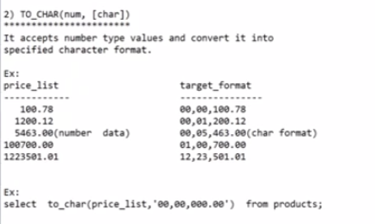

* Converts num values into char data.

But first we need to give some pattern in fun to_char(number, pattern)

SQL> select sal from emp;

SAL

----------

5000

2850

2450

2975

3000

3000

800

1600

1250

1250

1500

SAL

----------

1100

950

1300

14 rows selected.

SQL> select to_chat(sal,'0000.00') from emp;

select to_chat(sal,'0000.00') from emp

*

ERROR at line 1:

ORA-00904: "TO_CHAT": invalid identifier

SQL> select to_char(sal,'0000.00') from emp;

TO_CHAR(

--------

5000.00

2850.00

2450.00

2975.00

3000.00

3000.00

0800.00

1600.00

1250.00

1250.00

1500.00

TO_CHAR(

--------

1100.00

0950.00

1300.00

14 rows selected.

SQL> select sal, to_char(sal,'0000.00') from emp;

SAL TO_CHAR(

---------- --------

5000 5000.00

2850 2850.00

2450 2450.00

2975 2975.00

3000 3000.00

3000 3000.00

800 0800.00

1600 1600.00

1250 1250.00

1250 1250.00

1500 1500.00

SAL TO_CHAR(

---------- --------

1100 1100.00

950 0950.00

1300 1300.00

14 rows selected.

SQL> select sal, to_char(sal,'00000000.000') from emp;

SAL TO_CHAR(SAL,'

---------- -------------

5000 00005000.000

2850 00002850.000

2450 00002450.000

2975 00002975.000

3000 00003000.000

3000 00003000.000

800 00000800.000

1600 00001600.000

1250 00001250.000

1250 00001250.000

1500 00001500.000

SAL TO_CHAR(SAL,'

---------- -------------

1100 00001100.000

950 00000950.000

1300 00001300.000

14 rows selected.

SQL> select sal, to_char(sal,'0,00,00,000.000') from emp;

SAL TO_CHAR(SAL,'0,0

---------- ----------------

5000 0,00,05,000.000

2850 0,00,02,850.000

2450 0,00,02,450.000

2975 0,00,02,975.000

3000 0,00,03,000.000

3000 0,00,03,000.000

800 0,00,00,800.000

1600 0,00,01,600.000

1250 0,00,01,250.000

1250 0,00,01,250.000

1500 0,00,01,500.000

SAL TO_CHAR(SAL,'0,0

---------- ----------------

1100 0,00,01,100.000

950 0,00,00,950.000

1300 0,00,01,300.000

14 rows selected.

SQL> select sal, to_char(sal,'0,00,00,000.000') sal_in_char from emp;

SAL SAL_IN_CHAR

---------- ----------------

5000 0,00,05,000.000

2850 0,00,02,850.000

2450 0,00,02,450.000

2975 0,00,02,975.000

3000 0,00,03,000.000

3000 0,00,03,000.000

800 0,00,00,800.000

1600 0,00,01,600.000

1250 0,00,01,250.000

1250 0,00,01,250.000

1500 0,00,01,500.000

SAL SAL_IN_CHAR

---------- ----------------

1100 0,00,01,100.000

950 0,00,00,950.000

1300 0,00,01,300.000

14 rows selected.

SQL> select sal, to_char(sal,'0,00,00,000.000') sal_in_char from emp order by salary;

select sal, to_char(sal,'0,00,00,000.000') sal_in_char from emp order by salary

*

ERROR at line 1:

ORA-00904: "SALARY": invalid identifier

SQL> select sal, to_char(sal,'0,00,00,000.000') sal_in_char from emp order by sal;

SAL SAL_IN_CHAR

---------- ----------------

800 0,00,00,800.000

950 0,00,00,950.000

1100 0,00,01,100.000

1250 0,00,01,250.000

1250 0,00,01,250.000

1300 0,00,01,300.000

1500 0,00,01,500.000

1600 0,00,01,600.000

2450 0,00,02,450.000

2850 0,00,02,850.000

2975 0,00,02,975.000

SAL SAL_IN_CHAR

---------- ----------------

3000 0,00,03,000.000

3000 0,00,03,000.000

5000 0,00,05,000.000

14 rows selected.

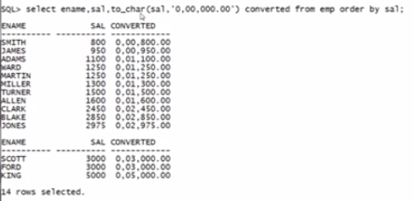

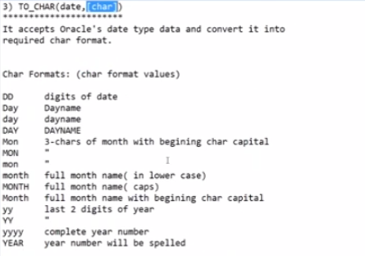

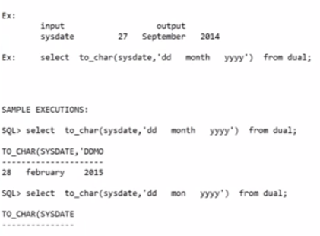

SQL> select to_char(sysdate, 'dd') from dual;

TO

--

14

SQL> select to_char(sysdate, dd) from dual;

select to_char(sysdate, dd) from dual

*

ERROR at line 1:

ORA-00904: "DD": invalid identifier

SQL> -- we need to give in single quotes as it is char

SQL> select to_char(sysdate, 'dd mon yy') from dual;

TO_CHAR(SYSDATE,'D

------------------

14 jan 21

SQL> select to_char(sysdate, 'date month yyyy') from dual;

select to_char(sysdate, 'date month yyyy') from dual

*

ERROR at line 1:

ORA-01821: date format not recognized

SQL> select to_char(sysdate, 'date month year') from dual;

select to_char(sysdate, 'date month year') from dual

*

ERROR at line 1:

ORA-01821: date format not recognized

SQL> select to_char(sysdate, 'dd mon yy') from dual;

TO_CHAR(SYSDATE,'D

------------------

14 jan 21

SQL> select to_char(sysdate, 'dd month yy') from dual;

TO_CHAR(SYSDATE,'DDMONTHYY')

------------------------------------------

14 january 21

SQL> select to_char(sysdate, 'dd month yyyy') from dual;

TO_CHAR(SYSDATE,'DDMONTHYYYY')

--------------------------------------------

14 january 2021

SQL> select to_char(sysdate, 'date month yyyy') from dual;

select to_char(sysdate, 'date month yyyy') from dual

*

ERROR at line 1:

ORA-01821: date format not recognized

SQL> select to_char(sysdate, 'dd mo yyyy') from dual;

select to_char(sysdate, 'dd mo yyyy') from dual

*

ERROR at line 1:

ORA-01821: date format not recognized

SQL> select to_char(sysdate, 'dd mon yyyy') from dual;

TO_CHAR(SYSDATE,'DDM

--------------------

14 jan 2021



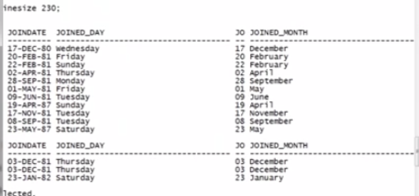

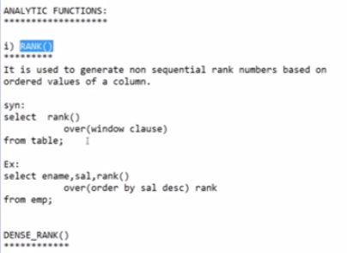

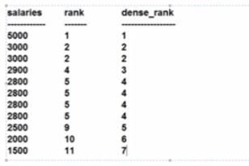

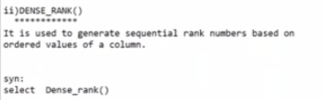

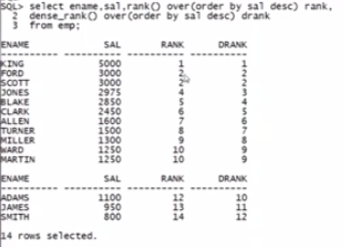

SQL> --generate rank, dens rank values based on desc order of emp sal

SQL> select ename, sal, rank() over(order by sal desc) eamcet_rank, dense_rank() over(order by sal desc) gate_rank from emp;

ENAME SAL EAMCET_RANK GATE_RANK

---------- ---------- ----------- ----------

KING 5000 1 1

SCOTT 3000 2 2

FORD 3000 2 2

JONES 2975 4 3

BLAKE 2850 5 4

CLARK 2450 6 5

ALLEN 1600 7 6

TURNER 1500 8 7

MILLER 1300 9 8

MARTIN 1250 10 9

WARD 1250 10 9

ENAME SAL EAMCET_RANK GATE_RANK

---------- ---------- ----------- ----------

ADAMS 1100 12 10

JAMES 950 13 11

SMITH 800 14 12

14 rows selected.